***P K Sarkar*** 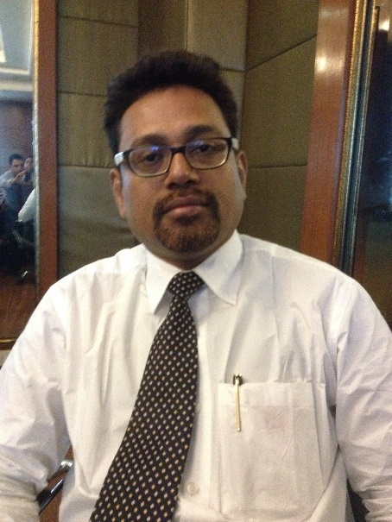

Address:

101A, Jaijinendra Apt

Ghatkopar East

Mumbai-78

Mobile No: 9619119835

E-Mail id : [pkmerck@gmail.com](mailto:pkmerck@gmail.com)

………………….............................................................................................................................................

***Synopsis:-***

* B.Sc.,MBA with 22 year of Sales & Marketing experience with MNC, Merck Ltd as Head of Sales .
* Managed 310 crs of business & delivering double digit Sales growth for the BU and gained market share in all the formats.
* Delivering superior performance by synchronizing engaging of 360 Sales team & 8 Marketing team
* Retention, Development & Motivating the team with 360 degree engagement.
* Formulation of Innovative marketing Ideas and out of box thinking, robust strategies, its implementations & follow-ups.
* Strong presence in the therapeutic areas of Phy, Paed, Cardio, GPs, Gyne, Gastro, Ortho, ENT ,Derma
* Planning & analytical skills to handle different complex situations.
* Strong communication and negotiation skills with the channel partners & other strategic business partners.
* A high degree of engagement & skills developments through different marketing activities.
* Increase the touch points of KOLs development through Pool & Push theory.

***Educational Qualifications:***

MBA,Ph.D

***Experiences:***

* Working from 1995 till date & have got 5 promotions, presently working as Head of Sales since 2014.
* Handling PAN India Sales & Marketing responsibilities with double digit CAGR
* Handling the business of 310 Crs , 360 Sales Team & 8 PMT.
* Entire team is nurtured /developed/ selected by myself

***Growth in Sales as a Manager***

|  |  |  |  |  |
| --- | --- | --- | --- | --- |
| ***Year*** | ***% Ach*** | ***Gr.*** | ***Desig.*** | ***Key achievements*** |
| *2016* | *93* | *9* | *SH* | *Stoped all QD* |
| *2015* | *95* | *17* | *SH* | *No.1 BU in Co.* |
| *2014* | *98* | *32* | *SH* | *Promoted as SH-HO* |
| *2013* | *99* | *27* | *SM* | *Add of West as SM* |
| *2012* | *101* | *13* | *MFS* | *Promoted as SM-HO* |
| *2011* | *103* | *56* | *MFS* | *Add. Of Soth* |
| *2010* | *99* | *29* | *ZSM* | *Promoted as MFS-Kol* |
| *2009* | *113* | *33* | *ZSM* | *No.1 ZSM across BU* |
| *2008* | *98* | *29* | *ZSM* | *Correction of PATNA* |
| *CAGR* |  | *27.2* |  |  |

***Carrier Growth in Merck from 1995***

Promoted as Head of Sales w.e.f July’14 based at Mumbai

|  |  |  |  |
| --- | --- | --- | --- |
| ***Year*** | ***Promotion*** | ***HQ*** | ***Key achievements*** |
| *2014* | *Head* | *Mumbai* | *PAN India no BU/Mkt Head* |
| *2012* | *SM* | *Mumbai* | *East & West* |
| *2010* | *MFS* | *KOLKATA* | *East & South* |
| *2008* | *ZSM* | *PATNA* | *No.1 ZSM across the BU's* |
| *2005* | *ASM* | *Guwahati* | *Top ASM* |
| *1995* | *MR* | *Siliguri* | *Highest PMPM* |

***Key Job Responsibilities as a Head of Sales:***

1. ***Budgeting, P&L Management***

Responsible for developing annual sales budgets & increasing the net profitability.

Implementing sales plan, building sales forecasting accuracy

Monitoring the sales performance and take corrective actions based on competition activities to achieve annual targets & minimize the expenses to Increase the net profitability.

1. ***Achieving Sales budget monthly /YTD***

Execution of trade marketing strategy to ensure efficient utilization of budgets.

KOLs development & engagement through different marketing activities such as DGM/Seminars/symposia.

Rural marketing initiatives to reach to unexplored markets.

Develop and drive the commercial and distribution strategy in conjunction with marketing and /BU management.

Drive sales team to implement channel expansion plans and throughout to achieve primary and secondary channel objectives for portfolio development.

1. ***Planning & Implementations of strategies***

Be the one-point contact and person responsible from AIL, for all Merck Branding execution at the POS in all channels (current and emerging).

Also, own and execute the coordination with other support system regarding the Medical Detailing with the help of ethical channel team.

1. ***Distribution & Channel management***

Channel Management, OTC Sales Management, Exploring rural opportunities

Co-ordination with SNO team, Forecasting accuracy, Inventory management

Co-ordination with Internal & External Associations to run the smooth business.

Formulating marketing strategies to engage whole sellers & retailers.

1. ***Man-management –Selection/retention/team motivation/elevation***

Man-power management i.e. correct allocation of manpower in the correct geographies.

Optimum utilization of resources, hand holding,

Talent pool creation & Motivation by assigning additional responsibilities

1. ***Launching of new products /strengthening of megabrands.***

***New Product Launching***

|  |  |  |  |
| --- | --- | --- | --- |
| ***Year*** | ***Product*** | ***%*** | ***Key achievements*** |
| *2015* | *Rifidor* | *95%* | *PAN India no BU/Mkt Head* |
| *2013* | *NFRF* | *158%* | *Nutraceutical Award* |
| *2013* | *SwyasthaYatra* | *117%* | *Introduce Project SwyasthaYatra* |
| *2013* | *SwyasthaYatra* | *Rural Initiatives* | *Global Bronze Award* |
| *2012* | *Poly-L* | *111%* | *Poly .grown by double digit* |
| *2011* | *Cosome LCD* | *140%* | *Low hanging fruit* |

***Award & Rewards***

|  |  |  |
| --- | --- | --- |
| ***Year*** | ***Key achievements*** | ***Recognition (Award/Reward)*** |
| *2016* | *Stopped all QD* | *Highest KRA Increased the highest profitability* |
| *2015* | *No.1 BU in Co.* | *Entered in Gastro portfolio.* |
| *2014* | *Promoted as SH-HO* | *Global Bronze Award* |
| *2013* | *Add of West as SM* | *Introduce Project SwyasthaYatra* |
| *2012* | *Promoted as SM-HO* | *5 ASMs got promotions* |
| *2011* | *Add. Of South* | *qualified Sunder ban prize trip with entire team* |
| *2010* | *Promoted as MFS-Kol* | *Nominated for Global Award* |
| *2009* | *No.1 ZSM across BU* | *Qualified London Prize trip with all ASMs* |
| *2008* | *Correction of PATNA* | *qualified Hong Kong prize trip as ASM* |
| *2007* | *Assessment Centre* | *Qualified Singapore trip as AMS* |

***Present Assignments:***

Seeing Govt. new policies w.e.f. 1st of Jan’17 I am assigned as new project lead of Super specialty Business such as NDD, Public Affairs, Market Access & Institutional Business of One Merck Healthcare.

***Personal Details:***

Languages known: English, Hindi, Bengali

D.O.B :28th Aug’1973.

Marital status: Married

Signature

(Dr.P K Sarkar)